Viktor Litvak |  | 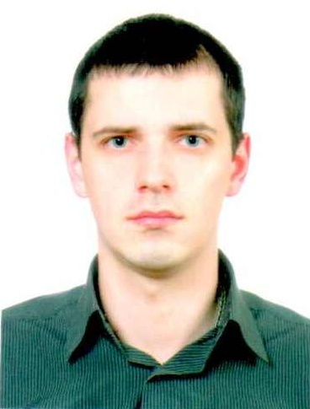
DOB | September 21, 1983
Phone | Mob. 097-94-715-94,  093-055-33-02
E-mail | viktor.lv.30@gmail.com
Address | Sitka Otamana St. 6/6, Vinnitsa, Ukraine, 21020
Marital status  Gender | married, have a daughter  male
Career Objective
Change my work direction to IT. An entry level position of a database administrator, prove my potential,
upgrade my knowledge and grow with the developing organization
Education
11.2015-  till date | Vinnitsa IT Academy. Studding programming (started from C/C++). Will learn other programming languages and main types of databases.
2005-2006 | Vinnitsa National Technical University, Management institute. Manager-economist.
2000-2005 | Vinnitsa National Technical University, Electric Engineering institute. Electrical engineer category 4.
WORK EXPERIENCE
In ITA  11.2015 - | Studding C/C++ languages.  Coding console Organizer and game – Tanks.
10.2007 – till date | Chief economist of the public joint-stock company Khreschatyk, Commercial Bank.  - work with reports in Excel;  - sale of banking products;  - work with insurance companies.
02.2007 – 08.2007 | Seller of electrical equipment
10.2006 – 01.2007 | Electric engineer LLC "Milius", Kiev, Ukraine  Support the work of electric part of equipment
Skills
• Good communications skills
• Excellent interpersonal skills
• Ability to handle stress and work in multitasking situations
• Highly organized and disciplined with a passion for Information Technology.
• Attentive, don’t smoke.

Additional Information | Driving license cat. A, B, C  Driving experience – from 2007.
Languages | English – beginner ~ pre-intermediate.
Hobbies and interests | Cars, gym.

